Lab assignment 6

U24cs076

Rushang bagada

1. With the transform property, move the <div> element 100px to the right, and 200px down.

<!DOCTYPE html>

<html>

<head>

<style>

div {

width: 100px;

height: 100px;

background-color: lightblue;

border: 1px solid black;

transform: translateX(100*px*) translateY(200*px*);

}

</style>

</head>

<body>

<div></div>

</body>

</html>

Output:

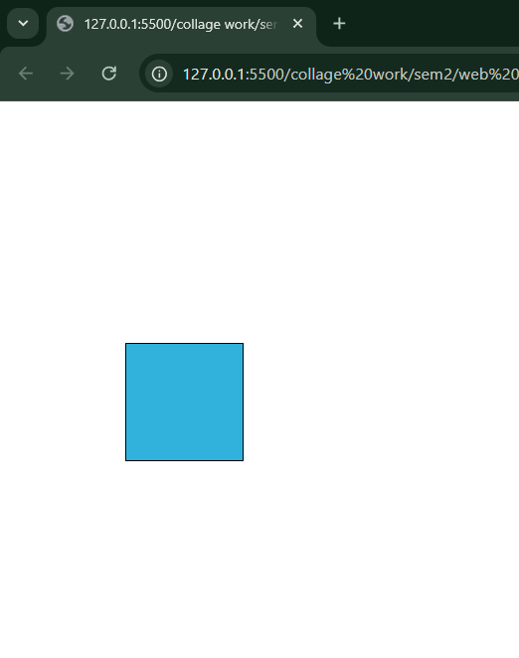

2. With the transform property, change the size of the <div> to half its width, but double its height.

<!DOCTYPE *html*>

<html>

<head>

    <style>

        div {

            width: 100*px*;

            height: 100*px*;

            margin: 50*px*;

            background-color: lightblue;

            border: 1*px* solid black;

            transform: scale(0.5,2);

        }

    </style>

</head>

<body>

    <div></div>

</body>

</html>

Output:

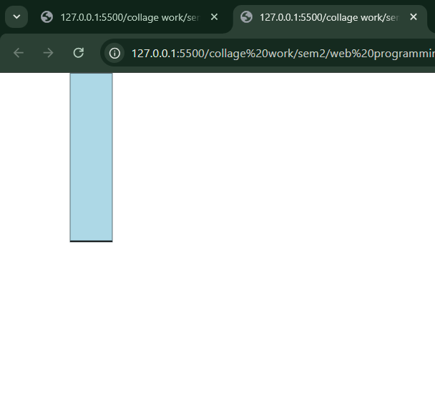

3. With the transform property, skew the <div> element 20 degrees along the X-axis, and 30

degrees along the Y-axis.

<!DOCTYPE *html*>

<html>

<head>

    <style>

        div {

            width: 100*px*;

            height: 100*px*;

            margin: 50*px*;

            background-color: lightblue;

            border: 1*px* solid black;

            transform: skew(20*deg*,30*deg*);

        }

    </style>

</head>

<body>

    <div></div>

</body>

</html>

Output:

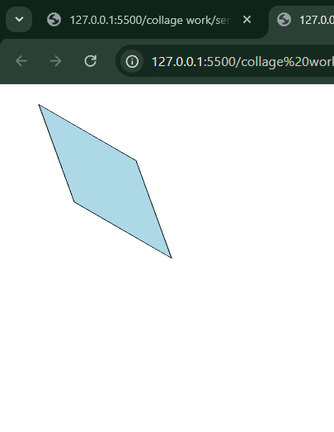

4. Add a 2 second transition eect for width changes of the <div> element.

<!DOCTYPE *html*>

<html>

<head>

    <style>

        div {

            width: 100*px*;

            height: 100*px*;

            background: red;

            transition: 2*s*;

        }

        div*:hover* {

            width: 300*px*;

        }

    </style>

</head>

<body>

    <div></div>

    <p>Hover over the div element above.</p>

</body>

</html>

Output:

Hover:

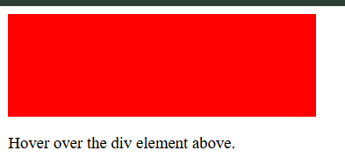

Without hover:

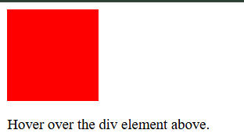

5. Specify that the transition of the <div> element should have a "0.5" second delay before

starting.

<!DOCTYPE *html*>

<html>

<head>

    <style>

        div {

            width: 100*px*;

            height: 100*px*;

            background: red;

            transition: width 2*s*;

            transition-delay: 0.5*s*;

        }

        div*:hover* {

            width: 300*px*;

        }

    </style>

</head>

<body>

    <div></div>

    <p>Hover over the div element above.</p>

</body>

</html>

Output:

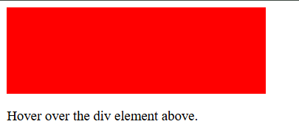

6. Using the transition shorthand property, specify width changes for the <div> element should

have: "2" second duration, "ease-in-out" speed curve, and a "0.5" second delay before

starting.

<!DOCTYPE *html*>

<html>

<head>

    <style>

        div {

            width: 100*px*;

            height: 100*px*;

            background: red;

            transition: 2*s*  ease-in-out;

            transition-delay: 0.5*s*;

        }

        div*:hover* {

            width: 400*px*;

        }

    </style>

</head>

<body>

    <div></div>

    <p>Hover over the div element above.</p>

</body>

</html>

Output:

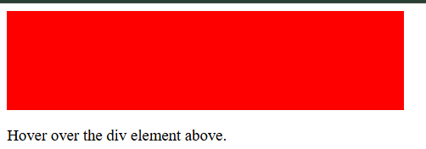

7. Add a 2 second animation for the <div> element, which changes the color from red to blue.

Call the animation “example"

<!DOCTYPE *html*>

<html>

<head>

    <style>

        div {

            width: 100*px*;

            height: 100*px*;

            background-color: red;

            animation: example 2*s*;

            animation-iteration-count: infinite;

        }

*@keyframes* example {

            50%{

                background-color: blue;

            }

        }

    </style>

</head>

<body>

    <div></div>

</body>

</html>

Output:



8. Specify that the animation of the <div> element should have a "1" second delay before starting.

<!DOCTYPE *html*>

<html>

<head>

    <style>

        div {

            width: 100*px*;

            height: 100*px*;

            position: relative;

            background-color: red;

            animation-name: example;

            animation-duration: 2*s*;

            animation-iteration-count: infinite;

            animation-delay: 1*s*;

        }

*@keyframes* example {

            0% {

                background-color: red;

                left: 0*px*;

            }

            50% {

                background-color: yellow;

                left: 200*px*;

            }

            100% {

                background-color: red;

                left: 0*px*;

            }

        }

    </style>

</head>

<body>

    <div></div>

</body>

</html>

Output:  
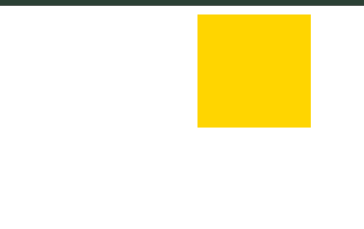

9. Specify that the animation of the <div> element should alternate between running forwards and

backwards.

<!DOCTYPE *html*>

<html>

<head>

    <style>

        div {

            width: 100*px*;

            height: 100*px*;

            position: relative;

            background-color: red;

            animation-name: example;

            animation-duration: 4*s*;

            animation-iteration-count: infinite;

            animation-direction: alternate;

        }

*@keyframes* example {

            0% {

                background-color: red;

                left: 0*px*;

                top: 0*px*;

            }

            25% {

                background-color: blue;

                left: 0*px*;

                top: 200*px*;

            }

            50% {

                background-color: green;

                left: 200*px*;

                top: 200*px*;

            }

            75% {

                background-color: yellow;

                left: 200*px*;

                top: 0*px*;

            }

            100% {

                background-color: red;

                left: 0*px*;

                top: 0*px*;

            }

        }

    </style>

</head>

<body>

    <div></div>

</body>

</html>

Output:

